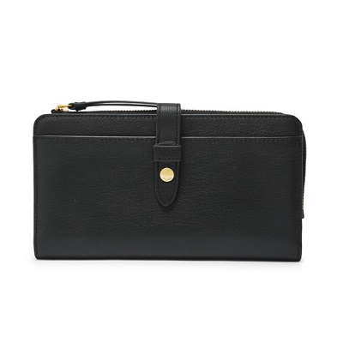

Fiona Tab Clutch

PRODUCT DETAILS

**Silhouette: Tab Clutch**

**Tech Compatibility: Front Slide Pocket: iPhone® 6, 7, 8**

**Exterior Material: Leather**

**Interior Details: 1 Bill Compartment, 1 ID Window, 1 Zipper Pocket, 9 Credit Card Slots**

**Measurements: 8"L x 1"W x 4.5"H**

**Warranty: 1 Year Limited**